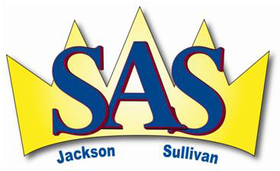
Parent Advisory Council Meeting
Minutes
Tuesday May 28, 2024 – In-person meeting @ Sullivan, 7:00 pm

- Call to Order:
Angela Dickson called the meeting to order at 7:00 pm

- Welcome & Introductions:
Angela Dickson (chair); Elayna Young (Treasurer); Michelle Wellingham (Secretary); Rob Cadden (Sullivan Principal); Gord Ritchie (Jackson Principal); Scott Hutchison; Andreas Meerza

Guest: Marianne VanBuskirk (Trustee)

- Adoption of Minutes:
Motion: to adopt Minutes from April 16, 2024
(Moved by: Scott Hutchison; Second: Andreas Meerza) Carried

- Treasurer’s Report: Elayna Young
Report on File for May 28, 2024.

No real change since last report ($3 difference)
Gaming account balance: $26,817 Chequing account balance = $2478.

5a. Principal’s Report –Jackson Campus: Gord Ritchie

Report on File

5b. Principal’s Report – Sullivan Campus: Rob Cadden

Report on File

6. DPAC Report
- Andreas has been unable to attend last 2 meetings; website still down.
- DPAC position remains open
- French Advisory Committee position remains open
- Old Business
- No old business

8. New Business
- Brief discussion about future of our PAC given upcoming District changes within next year+
- Discussion of hybrid option for PAC attendance, with Zoom option put forward (Andreas to investigate over summer)
- Call for other new business
  - Andreas initiated conversation about other avenues the PAC could move in terms of fundraising and community building activities
  - Mariane VanBuskirk attended in role as SD83 Trustee, primarily provided update about Long Range Facility Plan; corrected some incorrect information circulating

9. Adjournment 8:37 pm

Date of next PAC meeting: September 24 or 25 @ Jackson
**later confirmed as September 24 @ 7pm Jackson, with trial Zoom on September 17

Angela Dickson: President September 15, 2024
Name/Title Date

Signature

Michelle Wellingham: Secretary September 15, 2024
Name/Title Date

Signature

